Account ID and Password:

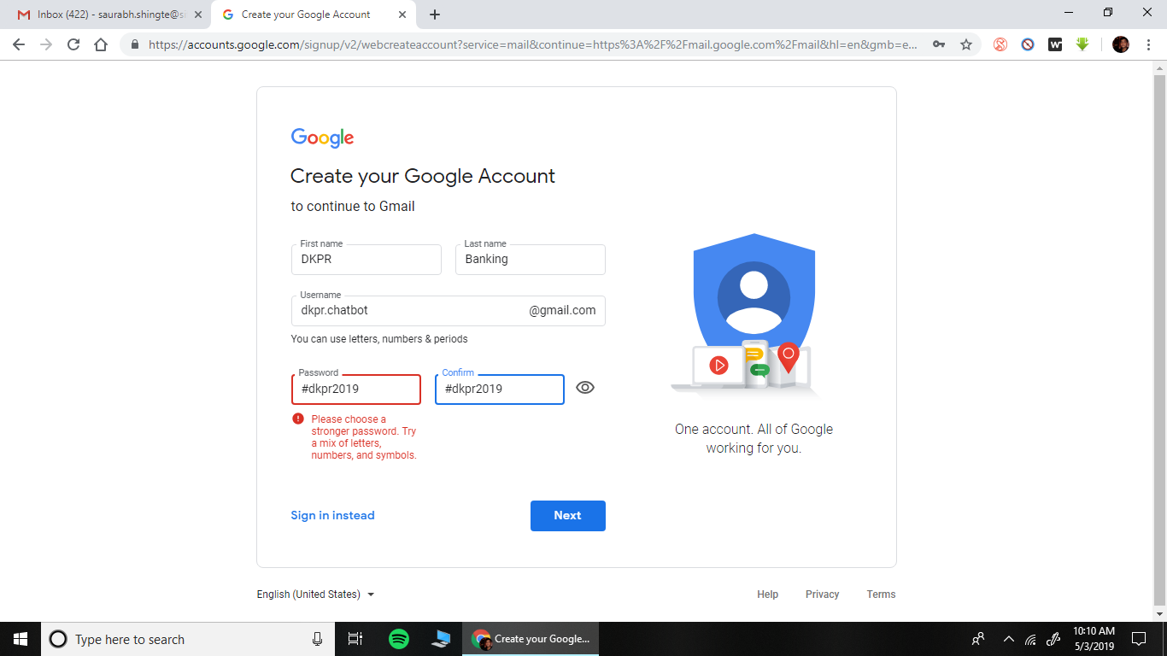

**Steps to verify the website for SEO:**

1. Go to the website: <https://www.google.com/webmasters/#?modal_active=none>
2. Sign in with the above given google account.
3. Select URL Prefix and enter the link of the FAQ Page. i.e. <http://learnbanking.in/chatbot/selection.php>

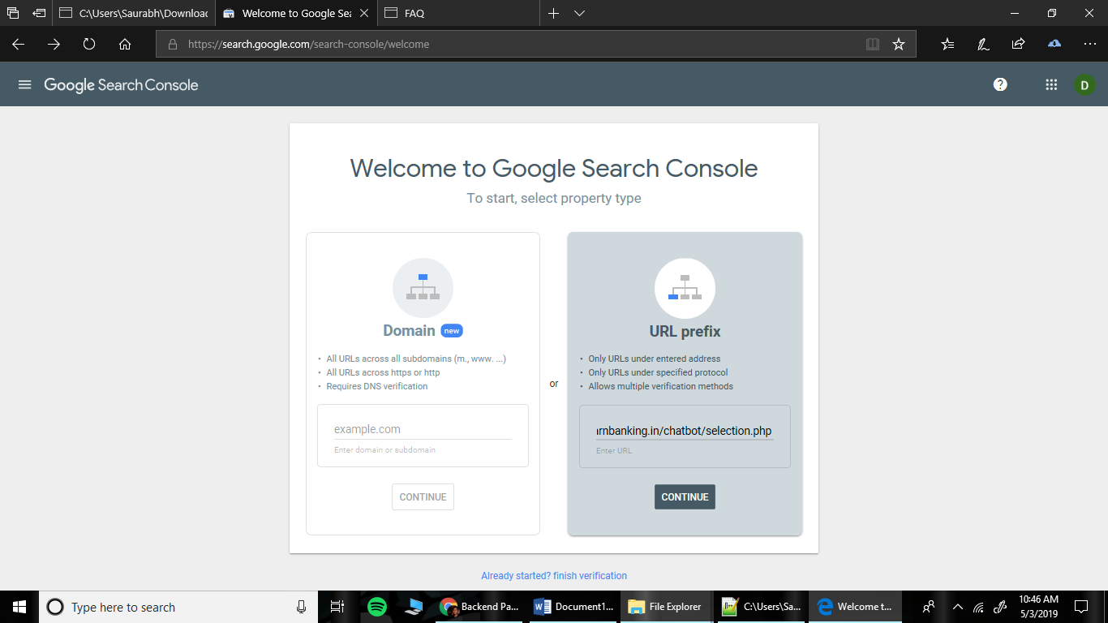

1. Select HTML tag from other verification methods.

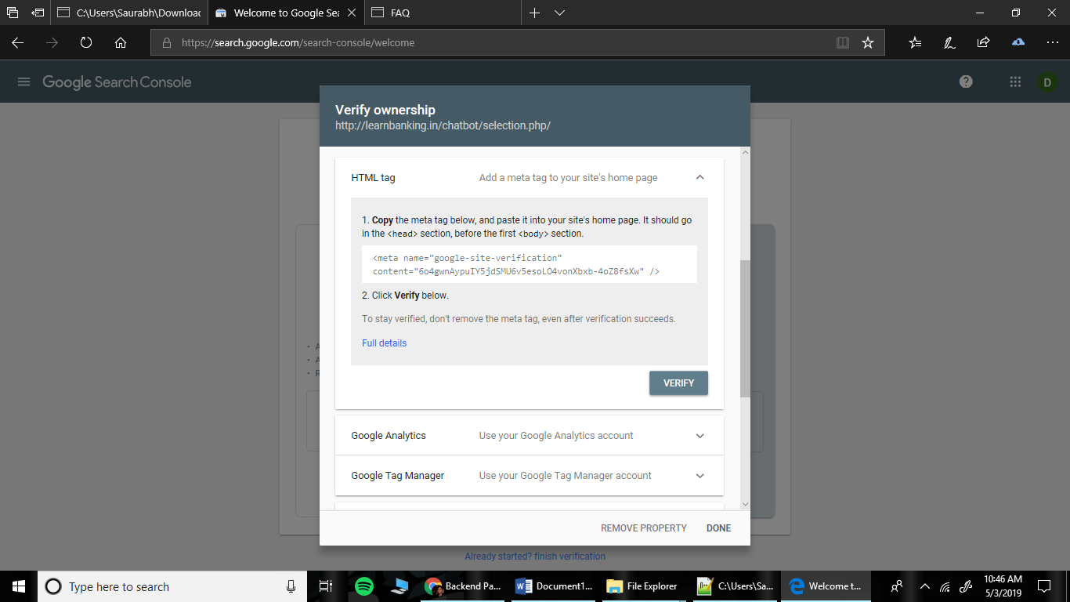

1. Copy paste the given text field and replace it in the seletion.php file.

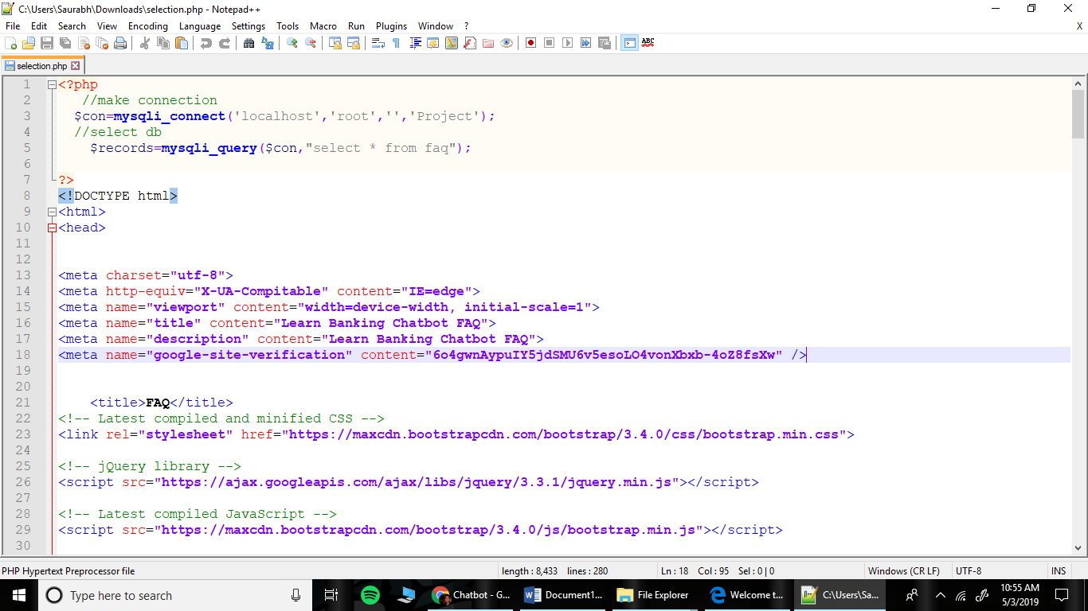

1. Upload the selection.php file on the database. And after it is done press verify.

**Steps to create knowledge base once the site gets indexed:**

1. Select FAQBot from Knowledge base.

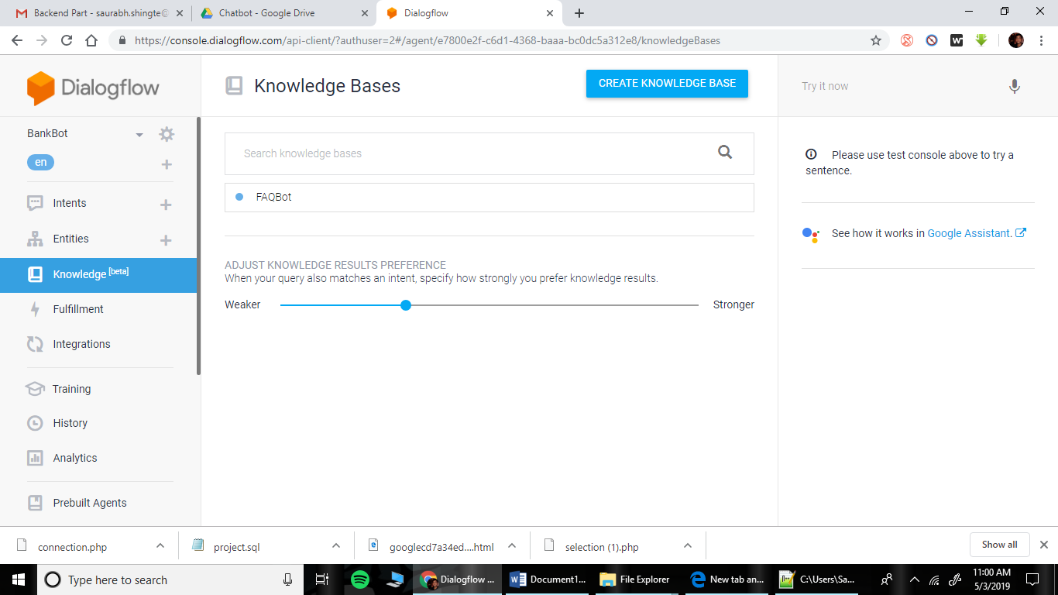

1. Click new document.

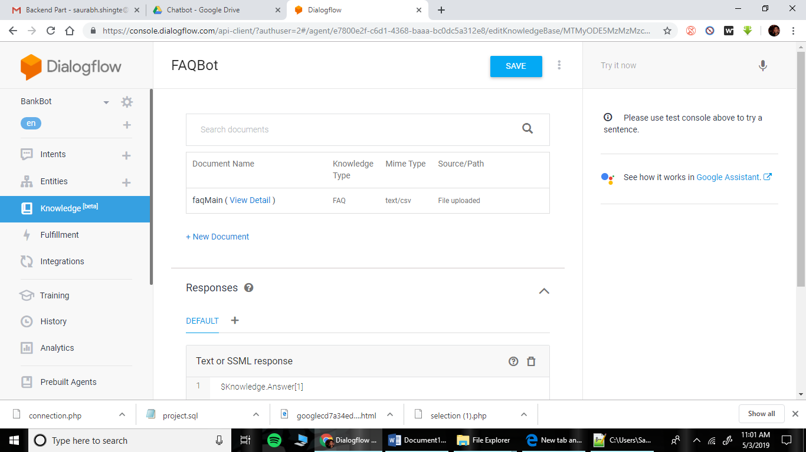

1. Input details as follows. And click create.

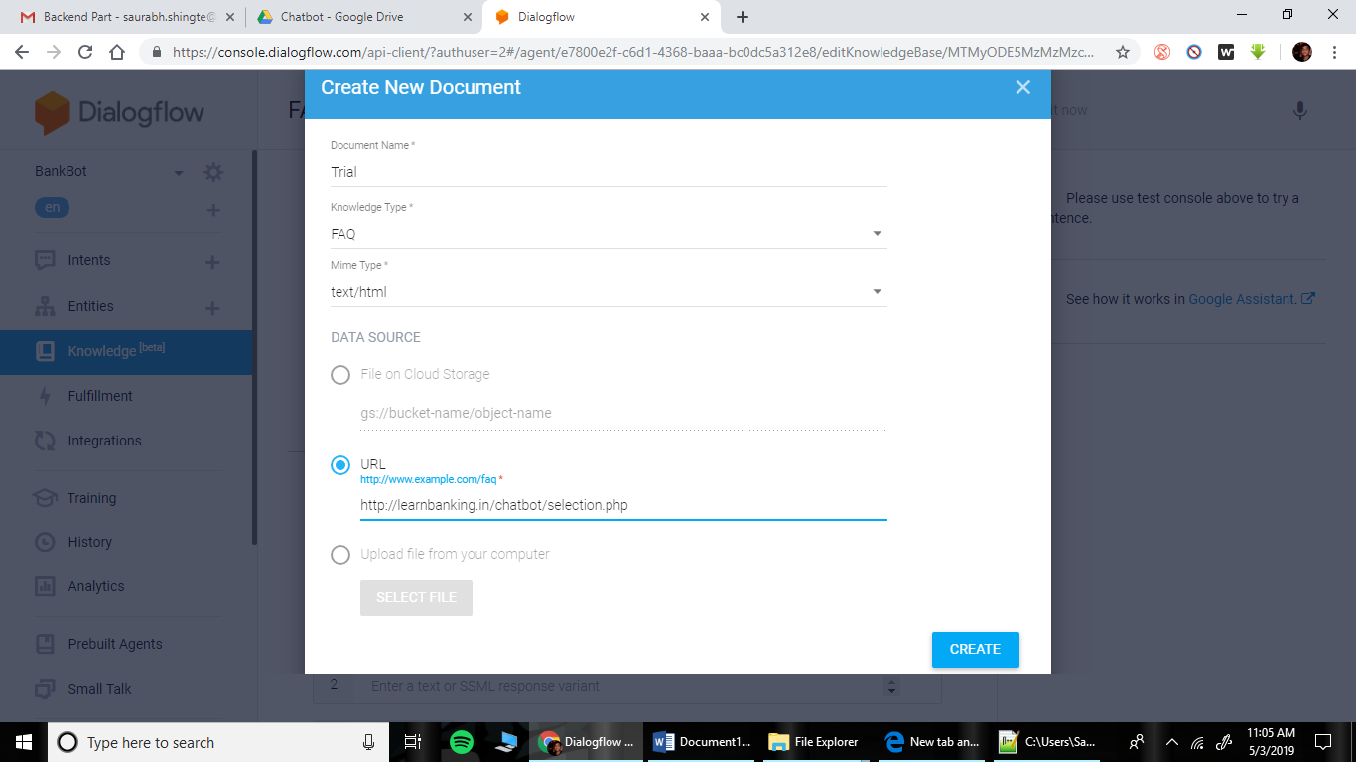

**NOTE:** If the site is indexed by Google then the agent training should start in a few seconds. If it is not indexed by it should show the following error.

